Limitations :
- No context is maintained. It doesn’t answer you when asked a follow up question.
- Too rigid and is rule based. Doesn’t understand anything beyond the rules and sample responses.
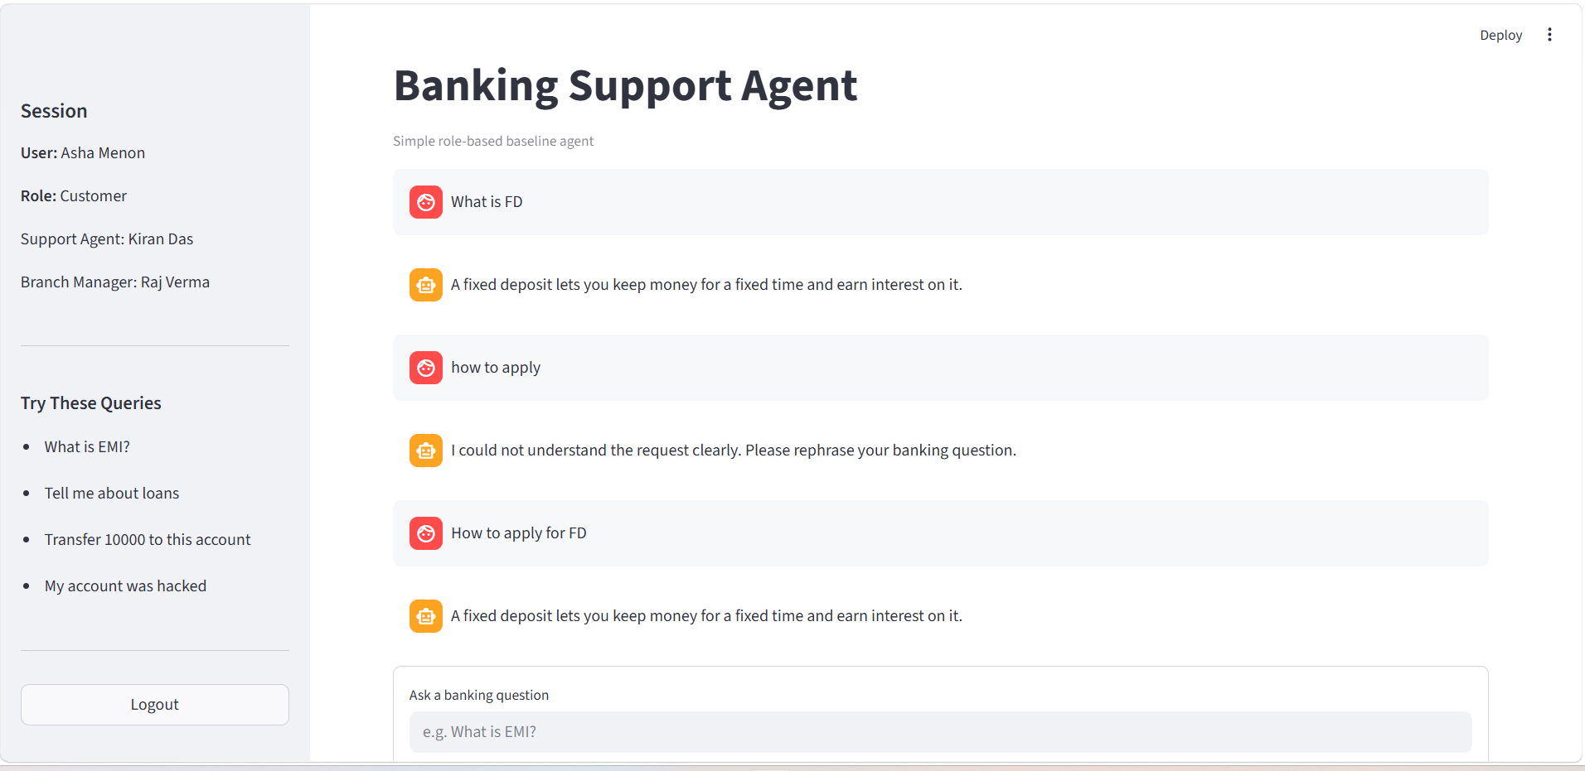

- It recognizes Transfer and immediately escalates but this is not actual Transfer money scenario:
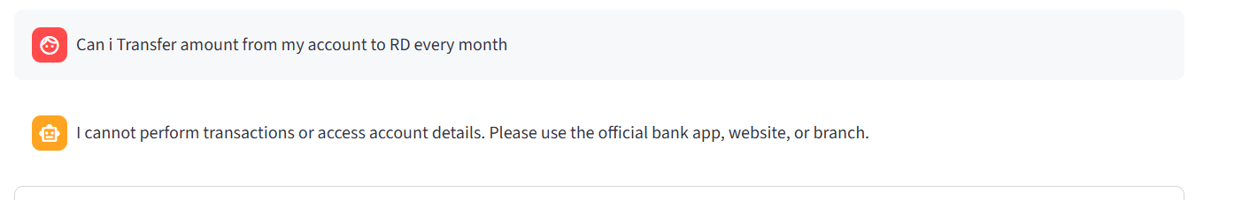

In the logs we can see that it has clearly mapped it to disallowed function but in reality its just a normal user query
Why this version is insufficient for real users
This version of the system has several practical limitations that impact usability, accuracy, and user trust in real-world scenarios.
1. No conversational context
The system does not retain previous interactions, so it fails to handle follow-up questions. Real users expect a continuous conversation (e.g., asking “What about tomorrow?” after a query). Without context awareness, the experience feels broken and repetitive, reducing usability.

2. Overly rigid, rule-based behavior
The system relies heavily on predefined rules and sample responses. This makes it brittle — it cannot generalize beyond what it has been explicitly programmed for. Real users phrase questions in unpredictable ways, and such rigidity leads to incorrect or irrelevant responses, limiting scalability.

3. Incorrect intent classification (false escalation)
The system incorrectly flags certain keywords like “transfer” as high-risk actions and escalates them. However, not all mentions of “transfer” imply a financial transaction.
For example:
- A user might be asking about transfer policies, limits, or procedures
- But the system immediately treats it as a disallowed money movement request
This leads to:
- Poor user experience
- Unnecessary escalations
- Loss of trust in the system
Even though logs show correct mapping to a “disallowed function,” the interpretation is contextually incorrect, highlighting weak intent understanding.

🚫 Overall Impact
Due to these limitations, the system:
- Cannot handle natural conversations
- Misinterprets user intent
- Fails in real-world variability
👉 As a result, it is not yet suitable for deployment in a real banking or customer-facing environment.

